**Task 1:** Write a program in MIPS assembly language that takes input and display whether number is prime or not.

**Solution**

.data

promt:.asciiz"Enter Your Number : "

prime:.asciiz"Prime Number "

notprime:.asciiz"Not Prime Number"

.text

.globl main

main:

addi $t4,$zero,0

addi $t5,$zero,1

li $v0,4

la $a0,promt

syscall

li $v0,5

syscall

move $t0,$v0

li $t1,2

start:

bgt $t1,$t0,decide

div $t0,$t1

mflo $t2

mfhi $t3

beqz $t3,count

decide:

bge $t4,2,notprimenumber

addi $t1,$t1,1

bge $t3,$t5,start

b primenumber

count:

addi $t4,$t4,1

addi $t1,$t1,1

b start

primenumber:

li $v0,4

la $a0,prime

syscall

b exit

notprimenumber:

li $v0,4

la $a0,notprime

syscall

b exit

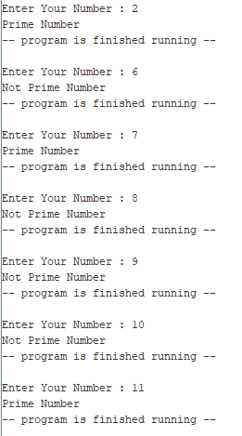exit:

li $v0,10

syscall

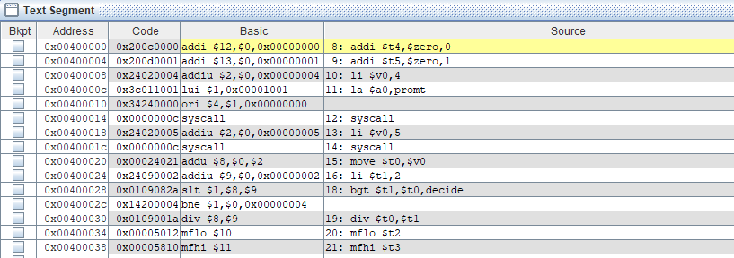**Output**

**Task 2:** Write a program in MIPS assembly language that provide the sum from 1 to 99 using for Loop

**Solution**

.data

tab:.asciiz"\t"

nextline:.asciiz"\n"

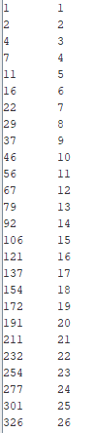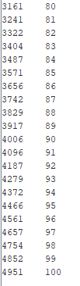

.text

.globl main

main:

addi $t0,$zero,1

addi $t1,$zero,0

loop:

add $t0,$t0,$t1

li $v0,1

move $a0,$t0

syscall

addi $t1,$t1,1

li $v0,4

la $a0,tab

syscall

li $v0,1

move $a0,$t1

syscall

li $v0,4

la $a0,nextline

syscall

beq $t1,100,exit

b loop

exit:

li $v0,10

syscall

**Output**

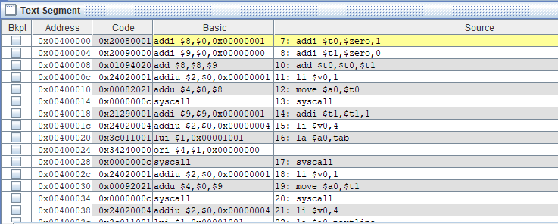

**Task 3:** Write a program in MIPS assembly language that takes input and display the Table.

**Solution**

.data

promt:.asciiz"Enter number : "

line:.asciiz"\n"

.text

.globl main

main:

li $v0,4

la $a0,promt

syscall

li $v0,5

syscall

move $t0,$v0

li $t1,1

loop:

mul $t2,$t0,$t1

move $a0,$t2

li $v0,1

syscall

li $v0,4

la $a0,line

syscall

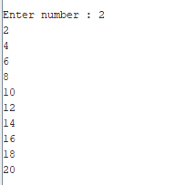addi $t1,$t1+1

blt $t1,11,loop

li $v0,10

syscall

**Output**

**Task 4:**

**Example**

**Solution**

.data

prompt: .asciiz "\n"

p1: .asciiz"ENTER SIZE OF LOOP: "

tab:.asciiz"\t"

decrement:.asciiz"\nDecrement :\n\n "

increment1:.asciiz"\nIncrement : \n\n"

.text

.globl main

main:

la $a0,p1 #print

li $v0,4

syscall

li $v0,5

syscall

move $t0,$v0

move $t3,$v0

subi $t3,$t3,1

li $v0,4

la $a0,decrement

syscall

true:

bgtz $t0,loop

li $v0,4

la $a0,prompt

syscall

li $v0,4

la $a0,increment1

syscall

else:

ble $t0,$t3,increment

b exit

loop:

li $v0,1

move $a0,$t0

syscall

#Nextline

li $v0,4

la $a0,tab

syscall

subi $t0,$t0,1

b true

increment:

addi $t0,$t0,1

li $v0,1

move $a0,$t0

syscall

#Nextline

li $v0,4

la $a0,tab

syscall

b else

exit:

li $v0,10

syscall

**Output**

